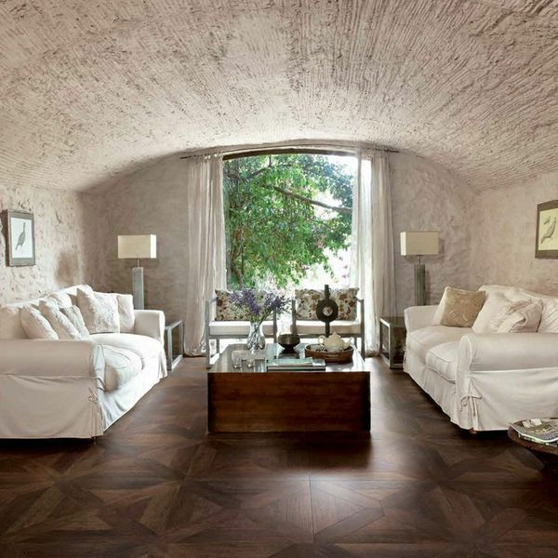**Vintage Wood Rovere Floor Tiles:**

## **Product Description**

This stunning, dark Rovere Floor Tile will add a luxury feel to your home. They're made from glazed porcelain, but the wood effect is incredibly realistic; with variating grains and knots. The parquet-effect joints look fantastic. You have to look very closely before you realise it isn't real varnished wood.

**What's special about these tiles?**

> Realistic wood effect design

> Luxurious parquet style

> Made from durable long-lasting porcelain

**Take a closer look**

Want to take a closer look at these tiles before placing a full order? Why not order a full-size sample tile? We send samples out with Free Delivery! They're the perfect way to see what a tile looks like in position in your home.

## **Product INFO**

* Product ID 12026
* Tiles Per SQM 4.3766740778348
* Sale by Per SQM
* Size 478x478x8mm
* Weight 4.33 KG
* Material Type Porcelain
* Finish Matt
* Colour Brown
* Suitability Floors
* Grade 5
* Rectified Edge No
* Underfloor Heating Yes
* Thickness (mm) 8